
Sierra Testbench Reference Manual, ver. 0.0.0
Sierra

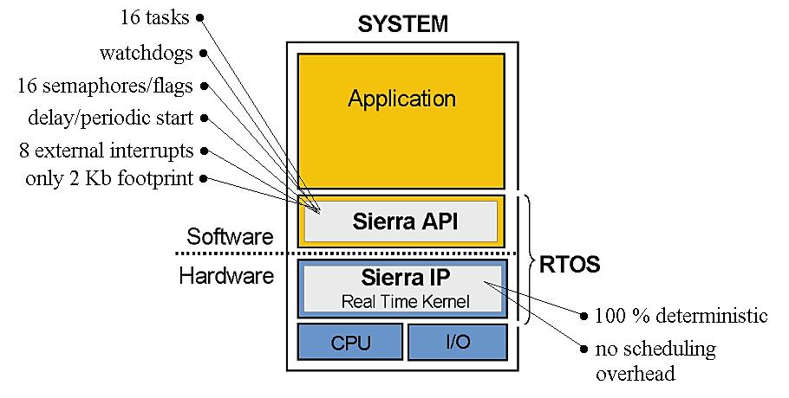

This manual describes how to use the Sierra test framework and how to extend it with new test cases. The framework is designed as a regression test environment, allowing previously validated functionality of the Sierra platform to be automatically verified whenever changes are made.

Some of the tests require a specific hardware configuration to run. A dedicated Sierra test platform exists that supports the complete set of tests. When this hardware platform is used, the full regression test suite can be executed.
If the software is run on other hardware platforms, only a subset of the tests can be executed. Tests that depend on the dedicated Sierra test hardware will automatically be skipped.
This behavior is controlled by the configuration parameter SIERRA_FULL_TEST_HW_PLATFORM, which is defined in the file test_setup.h.
- SIERRA_FULL_TEST_HW_PLATFORM = 1, The system is running on the dedicated Sierra test platform and all tests are enabled.
- SIERRA_FULL_TEST_HW_PLATFORM = 0, The system is running on a different hardware platform and only tests that do not require the special hardware are executed.
This mechanism allows the same test framework to be used both for full hardware validation and for development on simpler platforms, while maintaining a consistent regression testing process.

Copyright information
All rights reserved. All AGSTU AB source code or documents are an unpublished work, and the use of a copyright notice does not imply otherwise. All source code contains confidential, trade secret material of AGSTU. Any attempt at or participation in deciphering, decoding, reverse engineering, or in any way altering the source code is strictly prohibited unless the prior written consent of AGSTU AB is obtained.

Further information about the Sierra RTK can be found at www.agstu.com

Contact & Support

AGSTU AB (Måste tänka över)
Phone: +46 (0)70-6689517
Email: lennart.lindh@agstu.com
URL: www.agstu.com

Contents
Revision History 3
Terms 3
Sierra test framework 4
Adding New Tests 4
Hardware configurations and VS Code projects 5
Bilagor 6
A. How an Assertion Works 6

Revision History

Date | Description
2026-03-06 | Created

Terms
API | Application Programmers Interface, The sum of all function calls available to an application programmer
Application mode | A description of a complete system with scheduler, tasks etc. some RTOS allows the programmer to specify more than one mode. I.e., an aircraft control system may have different modes for takeoff, landing, and level flight.
Context switch (task switch) | Switch from current running task to another task by saving current task status, registers etc., and restore status of the task that shall start to run.
Embedded system | A computer system that forms a component of a larger system and is expected to function without human intervention.
Exception | Software interrupts.
Interrupt service routine (ISR) | The routine that is called when an interrupt occurs.
IP | Intellectual Property, this is HW/SW components with a specific function.
Real-time system | A real-time system is one in which the correctness of the system depends not only on the logical result of computation, but also on the time at which the results are generated.
RTOS | Real time operating system, an operating system designed to be used in real time systems.
Task/Thread/Process | A task is a sequential programming performing certain functions, a real time application is usually made up of one or more sets of communicating tasks.
TCB | Task control block, a structure containing information about a task, its state, stack owned resources, the value of the processor registers etc.

Sierra test framework

Structure of the Sierra Test Framework
Overview
The Sierra test framework is designed as a simple but structured regression testing system.
All tests are executed sequentially from sierra.c. New tests can be added easily.

Main Test File (sierra.c)
The entire test system is controlled from the main file, sierra.c.
This file is responsible for initializing, configuring the system time base, creating the idle task,
starting the scheduler and executing all tests in sequence. Once the system starts, the idle task
acts as the main controller for running the tests.

Idle Task Execution
All separate tests are executed from the idle task. The idle task contains an infinite loop where each test
is called one after another. Each test returns a value indicating whether it passed or failed.
A return value of 0 means the test passed. Any other value indicates a failure.
If a test fails, an error message is printed and an assertion stops the system, making it easy to
identify the failing test and the line where the error occurred.

Test Modules
Each Sierra function is tested in a separate module. For example, there are individual test modules
for task creation, task deletion, task blocking, priority scheduling, semaphores, flags, and time management.
The main test file includes all these modules and calls their test functions sequentially.

Test Configuration (test_setup)
General configuration parameters for the test environment are placed in a separate configuration file.
This file defines parameters such as stack sizes, task identifiers, and other settings used by the tests.
Using a configuration file allows the test environment to be modified without changing the test logic.

Regression Testing
The framework functions as a regression test system. All tests are executed automatically in a fixed order.
When new features are added to Sierra, new tests can be included while the existing tests ensure that
previous functionality continues to work correctly. If a test fails, execution stops immediately so the
problem can be identified quickly.

Adding New Tests

The Sierra test framework is designed to make it easy to extend the regression test suite. Each test is implemented as a separate source file and executed sequentially by the idle task. To add a new test case, follow the steps below.

1. Create a New Test File
Create a new source file for the test, for example: test_014_testing_xxx.c and header file, test_014_testing_xxx.h.
The header file typically only needs to declare the test entry function: int test_014_testing_xxx(void);
The header must also be included in sierra.c together with the other test headers.

This naming approach helps:
- group related tests together
- keep the numbering consistent
- avoid renumbering existing tests when new variants are added
The same naming convention should also be used for the corresponding header file, for example:
test_006C_testing_semaphore_xxx.h. In this example, the letter C indicates that the test belongs to the same functional group as test 006, but represents a specific variation or extension of that test.

This ensures that the test framework remains organized and easy to extend.

2. Implement a Test Entry Function
Each test file contains one main entry function that is called by the idle task.
Examples from the existing tests include:
test_001_testing_task_create()
test_002_testing_task_delete()
…..

Your new test should follow the same pattern: int test_014_testing_xxx(void)

The function should be returned:
0 => Test PASSED
1 => Test FAILED.

3. Use a Shared PASS/FAIL Variable
Most tests use a shared variable to store the test result. The variable is typically
initialized to FAIL and changed to PASS when the test conditions are satisfied.

Example:
static volatile int shared_pas_variable = 1;
When the test is successful: shared_pas_variable = 0;

4. Create the Tasks Required for the Test
Each test is responsible for creating its own tasks. These tasks perform the actions
needed to verify the behavior of the Sierra kernel. See example code.

5. Use Existing Task IDs and Stacks
The file test_setup.h defines task stacks, task IDs, stack size, and other shared resources.
The predefined tasks typically range from task_1 to task_7.

6. Add the Test to idle_task_code()
All tests are executed sequentially from the idle_task_code() function in sierra.c.

To include the new test, add a block like the following:

if (test_014_testing_xxx() == 0){printf("Test 14 PASSED");}else {printf("Test 14 Failed"); assert(0);}

This ensures that the test becomes part of the standard regression test sequence.

Hardware configurations and VS Code projects

All hardware and software required to run the Sierra test environment are in the directory:
SIERRA_FULL_TEST_HW_PLATFORM_NIOS. This directory contains both the FPGA hardware configuration and the corresponding software projects used with VS Code.

The hardware design includes the components required to support the Sierra real-time kernel test environment, while the software project contains the test framework and all associated test cases.

The hardware configurations provided support both Nios V-G and Nios V-M processor variants. The Sierra test system is fully supported on the DE10-Lite development board, which is used as the main hardware platform for development and validation.

The test environment can operate in two different modes depending on the available hardware platform. This is controlled by the compile-time parameter:
SIERRA_FULL_TEST_PLATFORM
- SIERRA_FULL_TEST_PLATFORM = 1
The system runs on the dedicated Sierra test platform, which includes the complete hardware configuration required for the test environment. In this mode all test cases are enabled and the full regression test suite can be executed.
- SIERRA_FULL_TEST_PLATFORM = 0
The software runs on a simplified or alternative hardware platform, such as a NIOS V with only a JTAGUART.

This configuration mechanism allows the same test framework to run both on the full Sierra validation platform and on smaller development systems based on the DE10-Lite board using either Nios V-G or Nios V-M processors and at least jtag_uart.

The dedicated Sierra test platform (SIERRA_FULL_TEST_PLATFORM = 1) consists of two distinct test environments: SIERRA_FULL_TEST_HW_PLATFORM_NIOSG and SIERRA_FULL_TEST_HW_PLATFORM_NIOSM.

SIERRA_FULL_TEST_HW_PLATFORM contains:
- NIOS V/g or NIOS V/m
- onchip_memory, 65kb
- log_memory, 8kb
- sdram, 64Mb
- jtag_uart
- jtag_uart_for_log, 512b (memory)
- pll
- sierra, rtos accelerator
- pio_sierra_extirq
- timer_HW_IP
- pio_loop_counter
- pio_irq_buttons

For more information, download the full project.

NOT SIERRA_FULL_TEST_HW_PLATFORM require only:
- NIOS V/g or NIOS V/m
- jtag_uart
- The rest can be the application specific architecture

Bilagor

How an Assertion Works
An assertion is a programming tool used to verify that a specific condition in the program is true. It is mainly used during development and testing to detect errors early.
An assertion checks the condition. If the condition is true, the program continues running normally. If the condition is false, the program stops immediately and reports an error.
In C, assertions are typically written using the assert() macro from the standard library.
Example:
assert(x == 5);
This means:
- If x is equal to 5, the program continues.
- If x is not equal to 5, the program stops and prints an error message indicating where the assertion failed.
Assertions are useful because they make it easy to detect incorrect program behavior during testing. Instead of allowing the program to continue with invalid data or unexpected states, the assertion stops execution immediately so the problem can be identified and fixed.
In the Sierra test framework, assertions are used to verify that the kernel behaves as expected. For example, they can be used to check:

